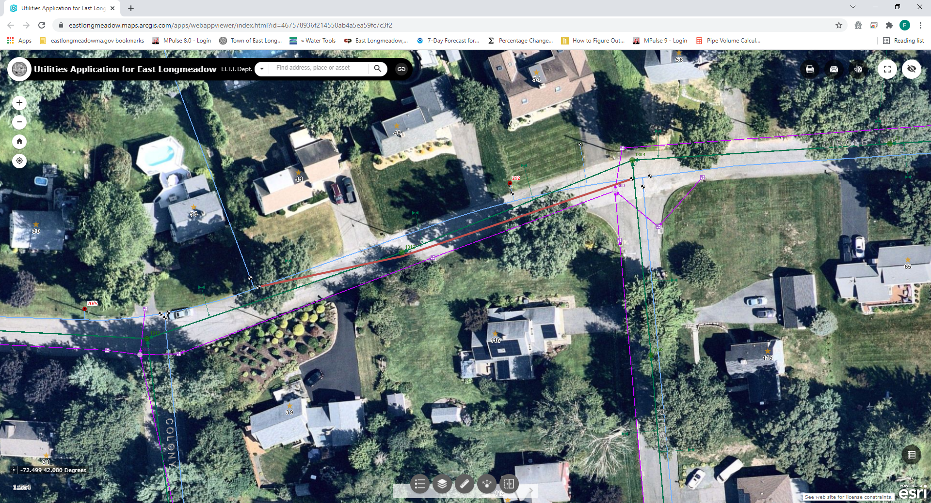

|  |  |  |  |  |
| --- | --- | --- | --- | --- |
| |  | | --- | | **Felix Vachon** | | AttachmentsFri, Nov 5, 6:50 AM (11 days ago) |  | https://mail.google.com/mail/u/0/images/cleardot.gif  https://mail.google.com/mail/u/0/images/cleardot.gif |
| |  | | --- | | to me  https://mail.google.com/mail/u/0/images/cleardot.gif | | | |

Mike,

The attached screenshot shows a more accurate picture of the 6" AC water main. It tucks up close to sewer manhole #1312

--

***Felix S. Vachon***

Water & Sewer Administrator

Town Of East Longmeadow DPW

Office: (413) 525-5400  Ext. 1204

Cell: (413) 246-4245

[felix.vachon@eastlongmeadowma.gov](mailto:felix.vachon@eastlongmeadowma.gov)

Most emails to and from municipal offices and officials are public record.  Confidentiality should not be expected.  However, this email, and any documents transmitted with it, may contain confidential or privileged information.  This information is only intended for use by the individual or entity to whom it is addressed.  If you are not the intended recipient, be aware that any disclosure, copying, distribution, or use of this information is prohibited.  If you have received this email in error, please notify us by returning this email or calling us at the number listed above and then deleting this email from your computer.